INTRODUCTION TO CIVIL ENGINEERING

PROJECT FILE

TOPIC

BUILDING CONSTRUCTION

NAME-ARYAN MISHRA

ID-2022UCE1102

INTRODUCTION

construction, also called building construction, the techniques and industry involved in the assembly and erection of structures, primarily those used to provide shelter. In its most widely used context, construction covers the processes involved in delivering buildings, infrastructure, industrial facilities and associated activities through to the end of their life. It typically starts with planning, financing, and design, and continues until the asset is built and ready for use; construction also covers repairs and maintenance work, any works to expand, extend and improve the asset, and its eventual demolition, dismantling or decommissioning.

The construction industry contributes significantly to many countries’ gross domestic products (GDP). Global expenditure on construction activities was about $4 trillion in 2012. Today, expenditure on the construction industry exceeds $11 trillion a year, equivalent to about 13 percent of global GDP. This spending was forecast to rise to around $14.8 trillion in 2030.

Some construction projects are small renovations or repair jobs, like repainting or fixing leaks, where the owner may act as designer, paymaster and labourer for the entire project. However, more complex or ambitious projects usually require additional multi-disciplinary expertise and manpower, so the owner may commission one or more specialist businesses to undertake detailed planning, design, construction and handover of the work.

Construction provides real solutions for human needs. Job security is relatively high compared to other industries as there are so many projects developing at one a time. Most roles are well-paid and the industry as a whole is always changing, so work remains exciting and fulfilling.

COMPONENTS OF A BUILDING CONSTRUCTION

1. VERTICAL COLUMN

There are several types of columns which are used in different parts of structures. Column is a vertical structural member that carry loads mainly in compression. It might transfer loads from a ceiling, floor slab, roof slab, or from a beam, to a floor or foundations. Commonly, columns also carry bending moments about one or both of the cross-section axes. The three

types of column are discussed below:

1. Tied Columns- This type of column is commonly construction from reinforced concrete. Longitudinal reinforcement are confined within closely spaced tie reinforcement. It is estimated that 95% of all columns in buildings are tied.
2. Spiral Columns- Spiral column is also construction from reinforced concrete. In this type of column, longitudinal bars are confined within closely spaced and continuously wound spiral reinforcement. Spiral reinforcement provide lateral restrains (Poisson’s effect) and delays axial load failure (ductile).
3. Composite Columns- When the longitudinal reinforcement is in the form of structural steel section or pipe with or without longitudinal bars, it is called as a composite column. This type of column have high strength with fairly small cross section, in addition to exhibit good fire performance.
4. SLAB

A concrete slab is a common structural element of modern buildings, consisting of a flat, horizontal surface made of cast concrete. Steel-reinforced slabs, typically between 100 and 500 mm thick, are most often used to construct floors and ceilings, while thinner mud slabs may be used for exterior paving.

In many domestic and industrial buildings, a thick concrete slab supported on foundations or directly on the subsoil, is used to construct the ground floor. These slabs are generally classified as ground-bearing or suspended. A slab is ground-bearing if it rests directly on the foundation, otherwise the slab is suspended. For multi-story buildings, there are several common slab designs

1. CEMENT

A cement is a binder, a chemical substance used for construction that sets, hardens, and adheres to other materials to bind them together. Cement is seldom used on its own, but rather to bind sand and gravel (aggregate) together. Cement mixed with fine aggregate produces mortar for masonry, or with sand and gravel, produces concrete. Concrete is the most widely used material in existence and is behind only water as the planet's most-consumed resource.

Cements used in construction are usually inorganic, often lime or calcium silicate based, which can be characterized as hydraulic or the less common non-hydraulic, depending on the ability of the cement to set in the presence of water (see hydraulic and non-hydraulic lime plaster).

MAKING OF A BUILDING

1. Building plan

An architectural drawing or building plan is a technical drawing of a building (or building project) that falls within the definition of architecture. Architectural drawings are used by architects and others for a number of purposes: to develop a design idea into a coherent proposal, to communicate ideas and concepts, to convince clients of the merits of a design, to assist a building contractor to construct it based on design intent, as a record of the design and planned development, or to make a record of a building that already exists.

Architectural drawings are made according to a set of conventions, which include particular views (floor plan, section etc.), sheet sizes, units of measurement and scales, annotation and cross referencing.

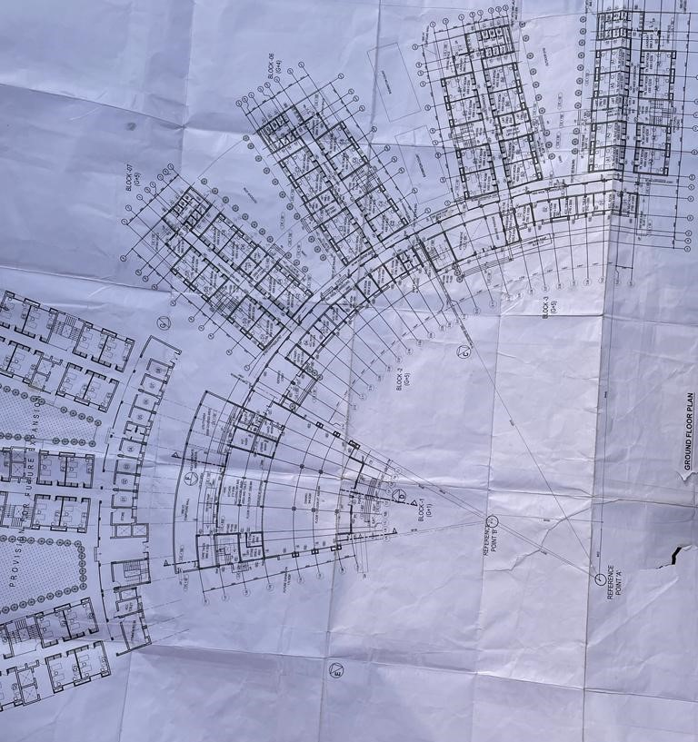

1. Site Clearing

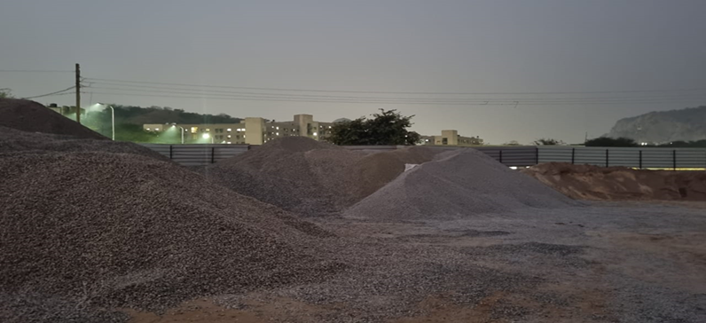

 The process of site clearance is generally undertaken as part of enabling works, carried out to prepare a site for construction. It involves the clearing the site to allow other remedial, treatment or demolition works to take place before the actual construction works can begin.

It involves clearing a site of any machinery or equipment, unwanted surplus materials, rubbish, and so on. Site clearance may also involve clearing away vegetation and surface soil, and levelling and preparing the ground for the planned construction works. Care should be taken to ensure that there are the correct approvals in place, particularly for trees which may be protected.

1. Foundation

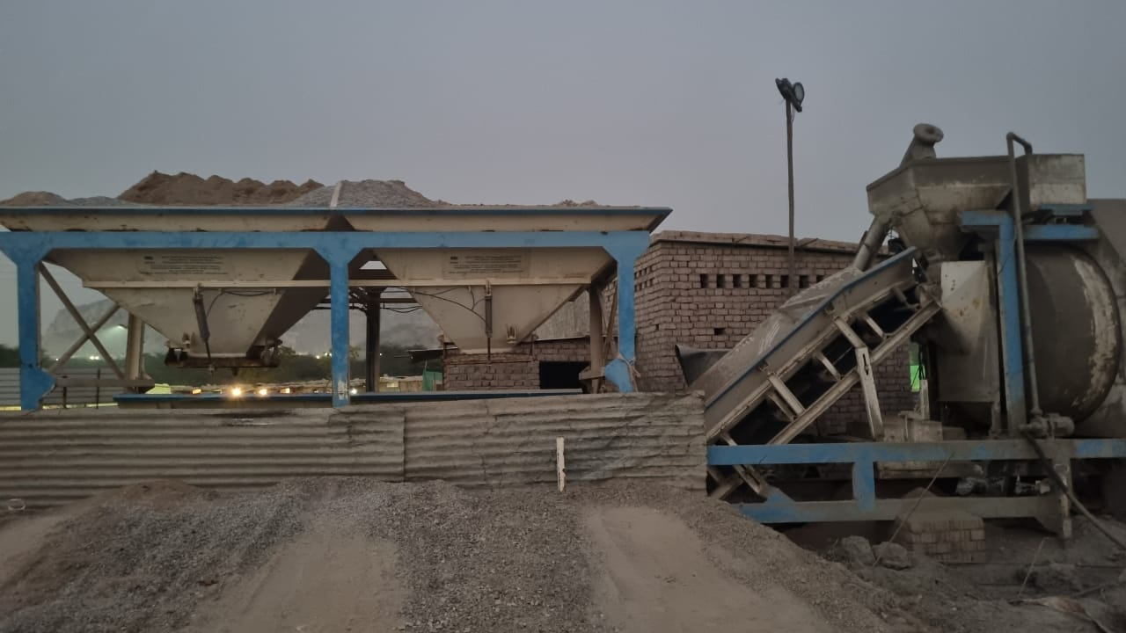

 To make a foundation, we normally dig a trench in the ground, digging deeper and deeper until we come to subsoil, which is more solid than the topsoil that is used to grow plants and crops. When the trench is deep enough, we fill it with any strong, hard material we can find.

1. Plinth beam and slab

A plinth beam is a type of beam that is provided at the ground level in a framed structure and is also known as a Tie Beam as it holds the columns in place. The length and slenderness ratio of a column is reduced by using plinth beams.

1. Superstructure

 The superstructure describes the entire portion of a building that sits above ground or the foundation. The superstructure is typically more extensive than the substructure depending on the type and size of the building.

1. Bricklaying

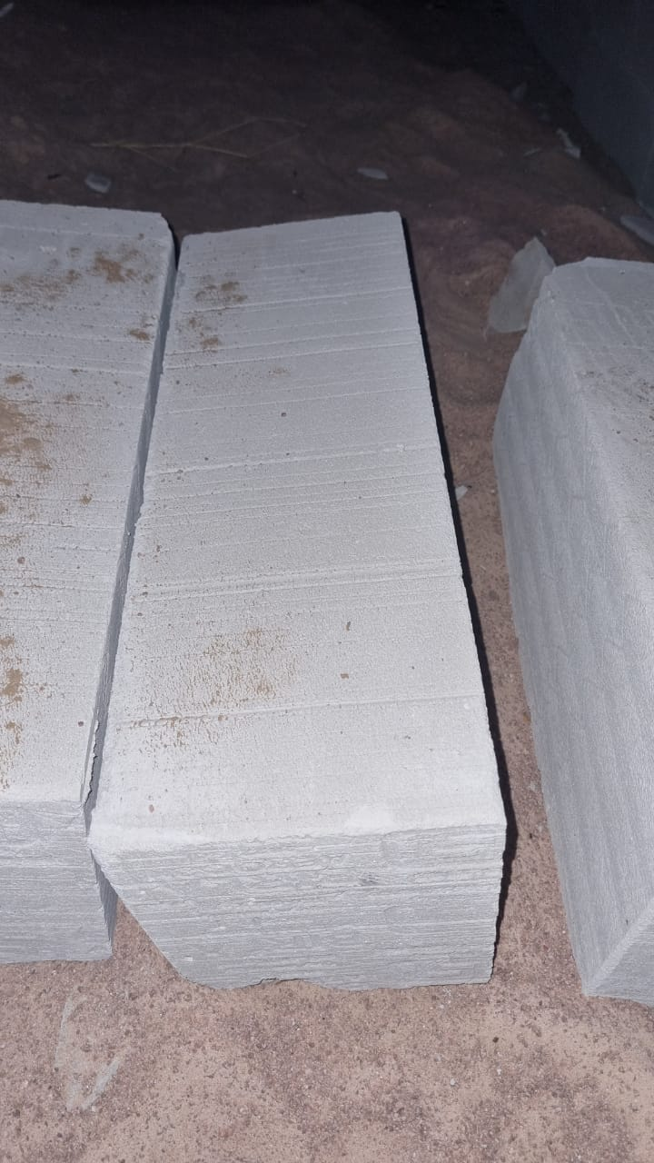

 Bricklayers lay bricks, concrete blocks, stone and other similar materials to construct or repair walls, arches, chimneys, fireplaces and other structures in accordance with blueprints and specifications. You could be installing firebrick in commercial and industrial furnaces and incinerators. You could also be working with acid tile and acid brick in pulp mills.

1. The Lintel

 A lintel or lintol is a type of beam (a horizontal structural element) that spans openings such as portals, doors, windows and fireplaces. It can be a decorative architectural element, or a combined ornamented structural item. In the case of windows, the bottom span is instead referred to as a sill, but, unlike a lintel, does not serve to bear a load to ensure the integrity of the wall. Modern day lintels are made using prestressed concrete and are also referred to as beams in beam and block slabs or ribs in rib and block slabs. These prestressed concrete lintels and blocks are components that are packed together and propped to form a suspended floor concrete slab.

1. Roof coating

A roof coating is a monolithic, fully adhered, fluid applied roofing membrane. Many roof coatings are elastomeric, that is, they have elastic properties that allow them to stretch and return to their original shape without damage.

Typical roof coating dry film thickness vary from paint film thickness (plus or minus 0.075 mm (3 dry mils) to more than 1 mm (40 dry mils). This means a roof coating actually becomes the top layer of a composite roof membrane and underlying system. As such, the roof coating is the topmost layer of protection for the membrane, receiving the impact of sunlight (both infrared and ultraviolet (UV)), rain, hail and physical damage.